EXPLORATORY DATA ANALYSIS REPORT
Algerian Forest Fires Dataset
Data quality, distributions, outliers and feature relationships
Source notebook: eda.ipynb
Dataset file: Dataset/clean_dataset.csv
Tools: Python, pandas, NumPy, Matplotlib, Seaborn
Report date: 21 October 2026

1. Executive Summary
This report documents the exploratory data analysis (EDA) carried out in the accompanying notebook on a cleaned forest-fire dataset. Each record describes one day of weather conditions and Canadian Forest Fire Weather Index (FWI) system components, together with a binary label indicating whether a fire occurred.
- Size and quality: 243 rows and 15 columns, with no missing values in any column.
- Target balance: Classes is mildly imbalanced toward fire – about 137 fire days (56.4%) versus 106 non-fire days (43.6%).
- Strongest predictors: FFMC (r = 0.77), ISI (0.74) and FWI (0.72) correlate most strongly with fire occurrence; wind speed has almost no linear relationship with it.
- Distribution shape: Rain, DMC, DC, ISI, BUI and FWI are right-skewed with long upper tails; FFMC is left-skewed; Temperature and Ws are roughly bell-shaped.
- Multicollinearity: Several FWI-system features are almost redundant (DMC–BUI r = 0.98, DC–BUI r = 0.94, ISI–FWI r = 0.92), which matters for linear and distance-based models.

2. Dataset Overview
The notebook loads the data with pd.read_csv and inspects it using head(), dtypes and columns. The table below lists every column, its pandas data type and its meaning.
Column | Dtype | Description
day | float64 | Day of month (1–31)
month | float64 | Month (6 = June … 9 = September)
year | float64 | Year (2012 for all records)
Temperature | float64 | Midday temperature (°C)
RH | float64 | Relative humidity (%)
Ws | float64 | Wind speed (km/h)
Rain | float64 | Rainfall (mm)
FFMC | float64 | Fine Fuel Moisture Code (FWI system)
DMC | float64 | Duff Moisture Code (FWI system)
DC | float64 | Drought Code (FWI system)
ISI | float64 | Initial Spread Index (FWI system)
BUI | float64 | Buildup Index (FWI system)
FWI | float64 | Fire Weather Index (FWI system)
Classes | int64 | Target: 1 = fire, 0 = no fire
region | float64 | Region indicator (0 / 1)
Table 1. Columns in the dataset (descriptions follow the public UCI Algerian Forest Fires documentation; the notebook itself does not define them)
Observations are daily records from June to September 2012 (day, month and year range from 1–31, 6–9 and 2012 respectively). The first rows show early-June days with low fire-weather indices and Classes = 0, consistent with the start of the season.
Note. Several columns that are conceptually integers or categories (day, month, year, region) are stored as float64. This is harmless for EDA but is worth casting to int before modelling.

3. Data Quality Checks

3.1 Missing values
Running df.isnull().sum() returned 0 for every column, and the total count of missing values is 0. No imputation is required.

3.2 Value ranges
Minimum and maximum values were computed for the 14 non-region columns. All values fall in plausible ranges for the meteorological and FWI variables:
- Temperature spans 22–42 °C and relative humidity spans 21–90%.
- Wind speed spans 6–29 km/h; rainfall spans 0–16.8 mm.
- FFMC spans 28.6–96.0, DMC 0.7–65.9, DC 6.9–220.4, ISI 0.0–19.0, BUI 1.1–68.0 and FWI 0.0–31.1.
- Classes contains only 0 and 1; the date fields confirm a single season (2012, months 6–9).
No impossible or negative values were found, so no records need to be removed on data-quality grounds.

4. Outlier Analysis
A boxplot was drawn for every column in the notebook (the complete set for the ten continuous variables is in Appendix A). To summarise them, the table below applies the standard 1.5 × IQR rule to the quartiles reported by describe(); points beyond the fences are the dots drawn by the boxplots.
Variable | Lower fence | Upper fence | Points beyond fences | Comment
Temperature | 22.5 | 42.5 | Low (22 °C) | Mild – a single cool day
RH | 21.0 | 105.0 | None | Min sits exactly on the lower fence
Ws | 9.5 | 21.5 | Low and high (6; 26–29) | A few calm / very windy days
Rain | –0.75 | 1.25 | High (up to 16.8 mm) | Many – most days are dry
FFMC | 47.2 | 113.0 | Low (down to 28.6) | Rainy-day tail
DMC | – | 43.3 | High (up to 65.9) | Late-season buildup
DC | – | 154.2 | High (up to 220.4) | Late-season drought
ISI | – | 16.0 | High (up to 19.0) | Few extreme-spread days
BUI | – | 47.6 | High (up to 68.0) | Late-season buildup
FWI | – | 27.6 | High (up to 31.1) | Few extreme-danger days
Table 2. IQR fences and where outliers occur
Most flagged points are genuine extremes rather than errors. For instance, the highest rainfall values (up to 16.8 mm) are real wet days, and the high DMC, DC and BUI values occur naturally as the dry season progresses. Rain is the most affected variable because over half of all days have no rainfall, so almost any wet day sits beyond the upper fence.
Recommendation. Do not delete these points. If a model is sensitive to extremes, use a transformation (e.g. log1p) or a robust scaler instead.

5. Distributions of Variables
After the boxplots, the day, month and year columns were dropped, since they are date identifiers rather than predictors. Histograms (50 bins) were then plotted for the remaining 12 columns.
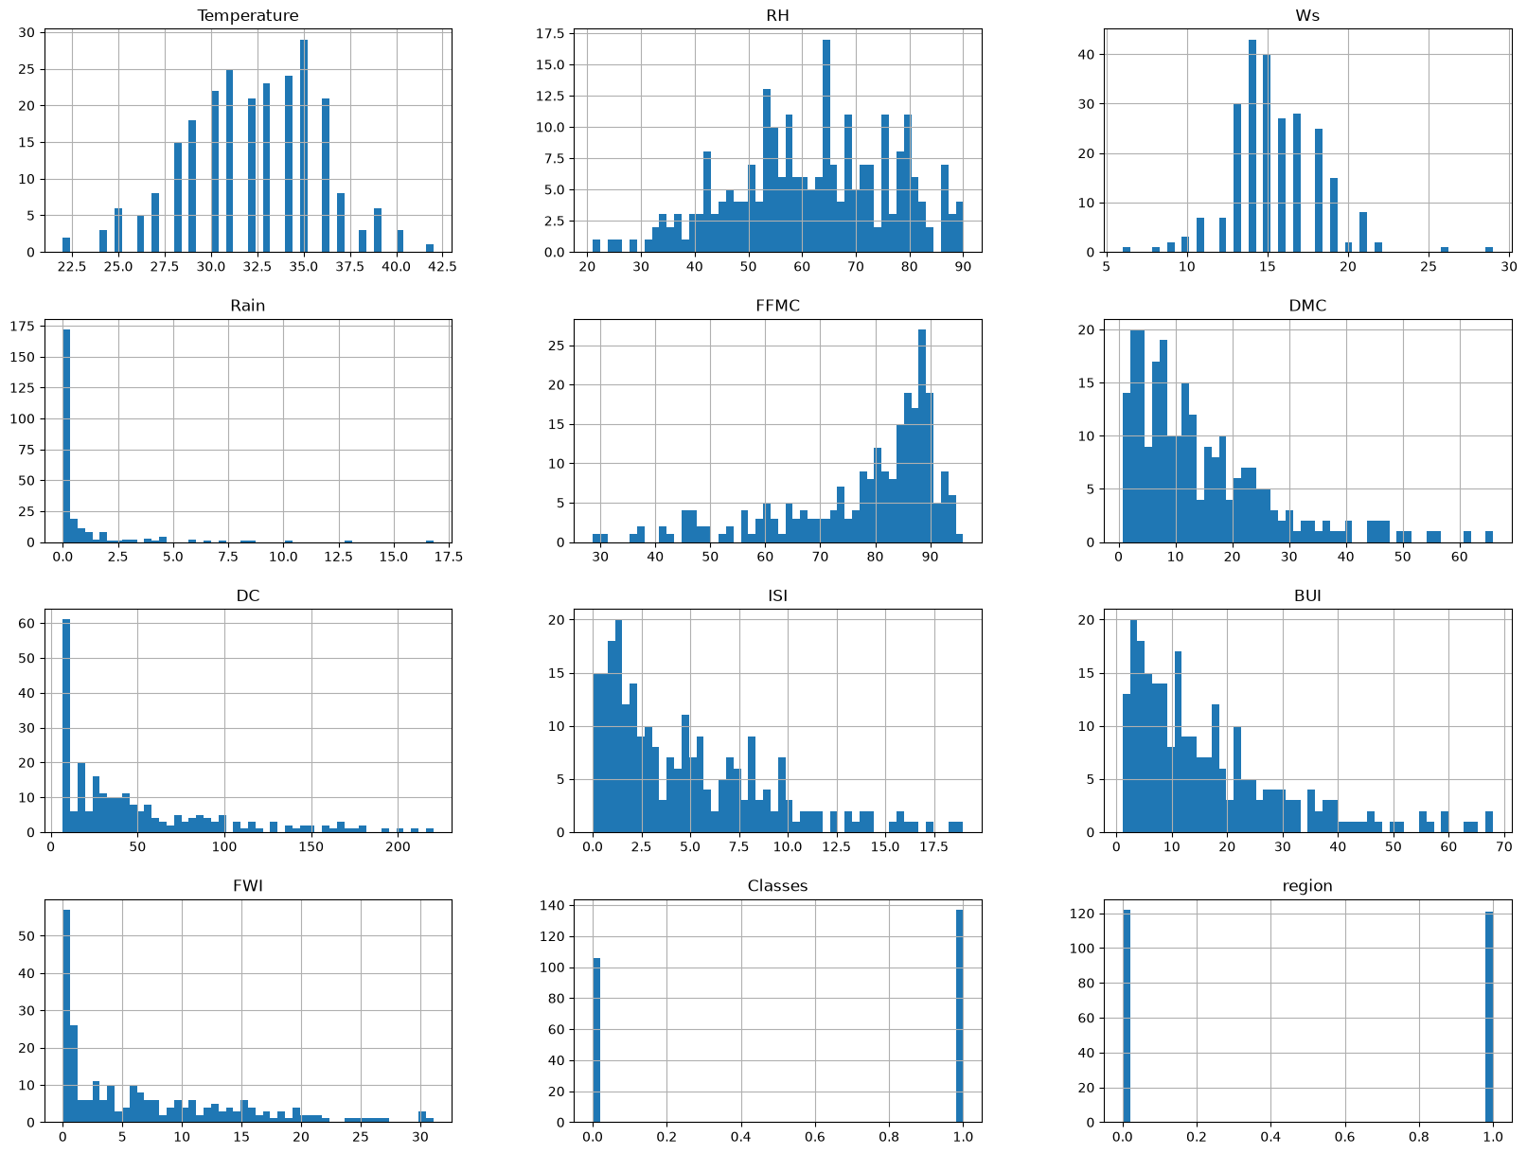
Figure 1. Histograms of all remaining variables

5.1 What the histograms show
- Temperature: approximately symmetric, centred near 32 °C (mean 32.2, median 32.0), with most days between 30 and 35 °C.
- RH: wide and fairly flat between 40% and 85% (mean 62.0, median 63.0).
- Ws: tightly bell-shaped around 14–16 km/h, with a few extreme values on either side.
- Rain: extremely right-skewed. The 75th percentile is only 0.5 mm, so the vast majority of days are dry.
- FFMC: left-skewed (mean 77.8 < median 83.3), with most days clustered at 80–92 and a thin tail of damp-fuel days.
- DMC, DC, ISI, BUI, FWI: all right-skewed (mean > median), with many days at low values and long upper tails. DC and FWI show a pronounced spike near zero.
- Classes: two bars, about 106 non-fire (0) and 137 fire (1) days – a modest imbalance.
- region: almost perfectly balanced, about 122 rows for region 0 and 121 for region 1.

6. Descriptive Statistics
Summary statistics from df.describe() are shown below (all 243 observations per variable).
Variable | Count | Mean | Std | Min | 25% | 50% | 75% | Max
Temperature | 243 | 32.15 | 3.63 | 22.0 | 30.0 | 32.0 | 35.0 | 42.0
RH | 243 | 62.04 | 14.83 | 21.0 | 52.5 | 63.0 | 73.5 | 90.0
Ws | 243 | 15.49 | 2.81 | 6.0 | 14.0 | 15.0 | 17.0 | 29.0
Rain | 243 | 0.76 | 2.00 | 0.0 | 0.0 | 0.0 | 0.5 | 16.8
FFMC | 243 | 77.84 | 14.35 | 28.6 | 71.85 | 83.3 | 88.3 | 96.0
DMC | 243 | 14.68 | 12.39 | 0.7 | 5.8 | 11.3 | 20.8 | 65.9
DC | 243 | 49.43 | 47.67 | 6.9 | 12.35 | 33.1 | 69.1 | 220.4
ISI | 243 | 4.74 | 4.15 | 0.0 | 1.4 | 3.5 | 7.25 | 19.0
BUI | 243 | 16.69 | 14.23 | 1.1 | 6.0 | 12.4 | 22.65 | 68.0
FWI | 243 | 7.04 | 7.44 | 0.0 | 0.7 | 4.2 | 11.45 | 31.1
Classes | 243 | 0.56 | 0.50 | 0.0 | 0.0 | 1.0 | 1.0 | 1.0
region | 243 | 0.50 | 0.50 | 0.0 | 0.0 | 0.0 | 1.0 | 1.0
Table 3. Descriptive statistics
The gap between mean and median confirms the skewness seen in the histograms. For example, DC has a mean of 49.4 against a median of 33.1, and FWI has a mean of 7.0 against a median of 4.2. The standard deviation of DC (47.7) is nearly as large as its mean, which signals high variability. Because the variables are on very different scales (RH up to 90, ISI up to 19, Rain up to 16.8), scaling will be needed for scale-sensitive algorithms.

7. Correlation Analysis
Pearson correlations were computed with df.corr() and visualised as an annotated heatmap.
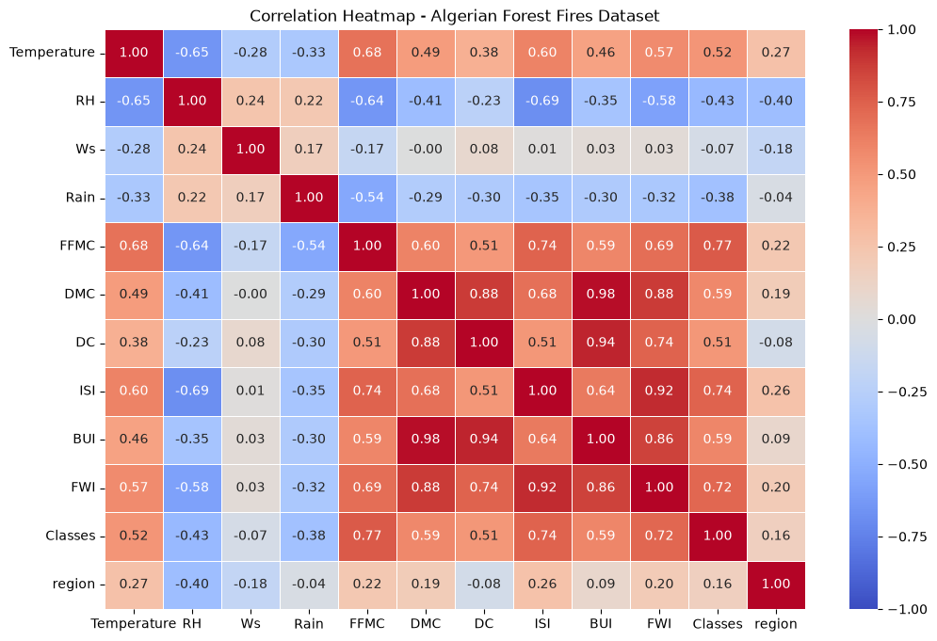
Figure 2. Correlation heatmap for the Algerian Forest Fires dataset

7.1 Relationship with the target (Classes)
Feature | Correlation with Classes | Strength
FFMC | 0.769 | Strong positive
ISI | 0.735 | Strong positive
FWI | 0.719 | Strong positive
BUI | 0.587 | Moderate positive
DMC | 0.586 | Moderate positive
Temperature | 0.516 | Moderate positive
DC | 0.511 | Moderate positive
RH | –0.432 | Moderate negative
Rain | –0.379 | Weak–moderate negative
region | 0.162 | Weak positive
Ws | –0.070 | Negligible
Table 4. Correlation of each feature with fire occurrence
FFMC, ISI and FWI are the most informative variables. This is expected: FFMC measures how dry the fine surface fuels are, and ISI and FWI build on it to describe fire spread and intensity. Temperature is positively associated with fire, while humidity and rainfall are negatively associated, matching physical intuition. Wind speed is almost uncorrelated with fire occurrence in this data.

7.2 Relationships between predictors
Weather variables are linked to each other: Temperature and RH are strongly negatively correlated (–0.65), Temperature and FFMC are positively correlated (0.68), and RH and FFMC are negatively correlated (–0.64). More importantly, the FWI-system indices are highly inter-correlated because they are calculated from one another:
Feature pair | Correlation
DMC – BUI | 0.982
DC – BUI | 0.942
ISI – FWI | 0.923
DMC – DC | 0.876
DMC – FWI | 0.876
BUI – FWI | 0.858
FFMC – ISI | 0.740
DC – FWI | 0.740
Table 5. Strongest pairwise correlations among predictors
Implication. DMC, DC and BUI carry largely overlapping information, as do ISI and FWI. Linear and logistic regression coefficients will be unstable if all are included together; consider dropping or combining some, or use regularisation or tree-based models.

8. Key Findings
- The dataset is clean: no missing values and all values fall in plausible ranges. (Duplicate rows were not checked in the notebook and are worth verifying.)
- Fire days make up 56% of records, so classes are only mildly imbalanced; accuracy alone is acceptable but precision, recall and F1 should also be reported.
- FFMC, ISI and FWI are the strongest univariate indicators of fire; Ws and region are weak.
- Many features are skewed with legitimate extreme values rather than erroneous outliers.
- Strong multicollinearity exists within the FWI-system indices.

9. Recommendations for Next Steps
- Cast types: convert region and Classes to integer or category dtype.
- Handle skew: apply log1p or Box–Cox/Yeo–Johnson to Rain, DMC, DC, ISI, BUI and FWI if using linear or distance-based models.
- Scale features: use StandardScaler (or RobustScaler given the outliers) for algorithms such as logistic regression, SVM and KNN.
- Reduce redundancy: check variance inflation factors (VIF) and consider removing BUI or combining DMC/DC/BUI; use regularisation where appropriate.
- Beware of leakage-like dependence: FWI is derived from ISI and BUI, which in turn derive from the weather and moisture codes. Decide deliberately which of these to feed a model, and compare results with and without FWI.
- Use stratified splits: apply stratified train/test splitting and cross-validation on Classes. Because the data is a single time series from one season, also consider a time-aware split to avoid optimistic estimates.
- Explore further: compare feature distributions for fire vs. non-fire days (grouped boxplots or violin plots), and examine differences between the two regions. Note that the date fields were dropped, so month-level seasonality is not captured in the current analysis.

Appendix A. Boxplots of Continuous Variables
Boxplots generated in the notebook for each continuous variable. The orange line is the median, the box spans the interquartile range, and circles mark points beyond 1.5 × IQR.
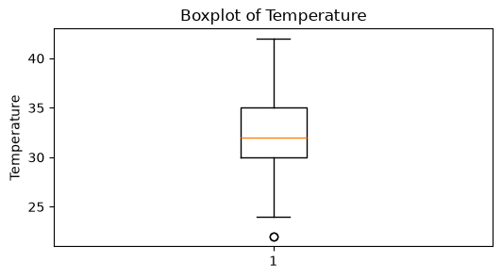 | 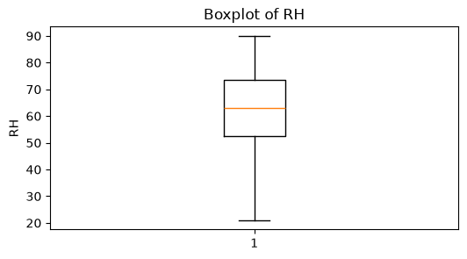
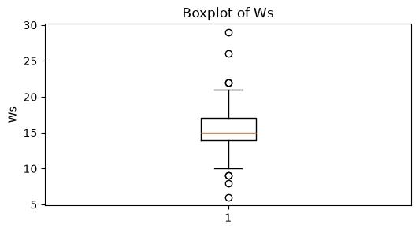 | 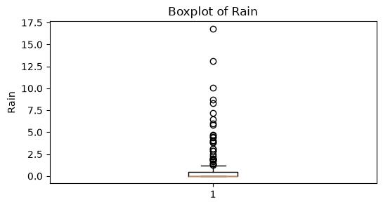
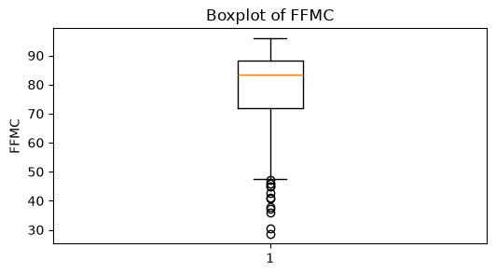 | 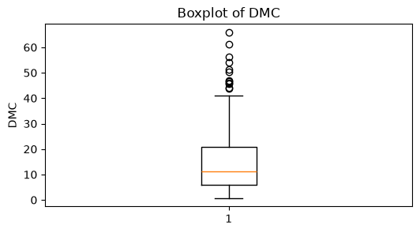
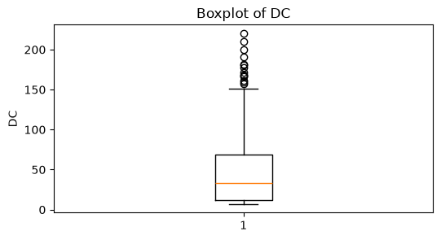 | 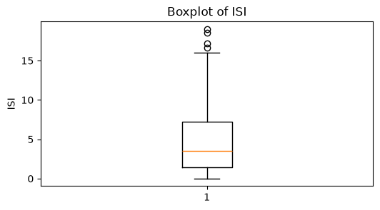
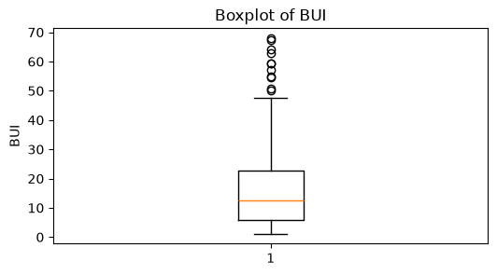 | 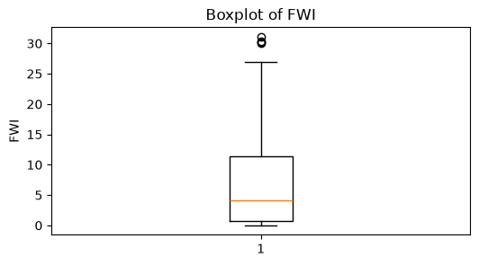
Figure A1. Boxplots: Temperature, RH, Ws, Rain, FFMC, DMC, DC, ISI, BUI, FWI
The notebook also produced boxplots for day, month, year, Classes and region. These are omitted here because they are date identifiers or binary variables, for which a boxplot is not informative.

Appendix B. Notebook Workflow Summary
Step | Operation | Purpose
1 | Import pandas, matplotlib, seaborn, numpy | Set up analysis tools
2 | pd.read_csv("Dataset/clean_dataset.csv") | Load the cleaned dataset
3 | head(), dtypes, columns | Inspect structure and types
4 | min() / max() of 14 columns | Check value ranges
5 | isnull().sum() | Check for missing values
6 | plt.boxplot for each column | Visual outlier detection
7 | drop day, month, year | Remove date identifiers
8 | df.hist(bins=50) | Examine distributions
9 | df.describe() | Summary statistics
10 | df.corr() and sns.heatmap | Correlation analysis

